apartment 56, Residence "LA ROSERAIE"
13 rue Aristide Briand, CENON

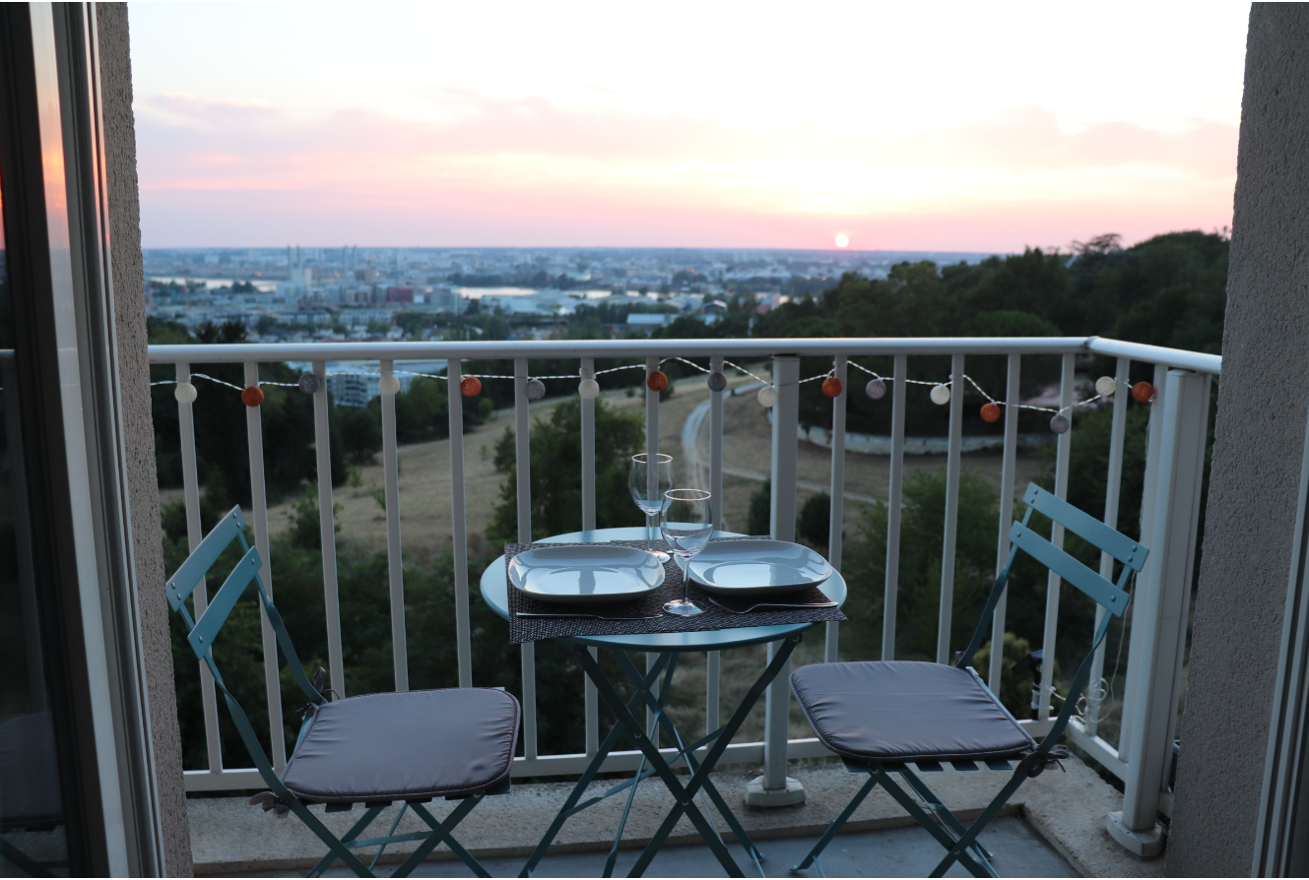

Welcome!

Having acquired this apartment in 2021, we put all our heart into renovating it and offering it today to travelers wishing to discover Bordeaux and the surrounding area.
As a reminder, as indicated in the Airbnb listing, this apartment is non-smoking and parties are not allowed.
We wish you a most comfortable and enjoyable stay in our apartment.
If necessary, we can be reached during your stay (Tel: 07 77 28 19 94, email: letourneurludovic0@gmail.com).

Ludovic

Table of Contents
Location Residence: 4
Access by public transport: 4
By tram 4
En TER + Tramway 5
Entrance to the residence's car park 6
Courses 7
WI-FI: 7
Radiator 7
Multimedia: 7
Television set: 7
Netflix 7
Chromecast : 7
Soundbar: 7
Outdoor fairy lights: 8
Sofa bed: 8
Cleaning: 8
Garbage 8
Outputs 9
Public transport 9
- Tram access from the street 9
- Tram access via Palmer Park 9
Near the apartment: 10
On the right bank of the Garonne: 12
The historic centre of Bordeaux 14
Places to visit 14
Your departure: 16

Location Residence:
The residence is located at 13 rue Aristide Briand in Cenon. At the gates of Bordeaux, its city centre is easily accessible by public transport and you have the advantage of enjoying a beautiful view of Bordeaux from a quiet accommodation in a green setting, and of benefiting from free parking.

Access by public transport:
From Bordeaux Airport
Tram A -> Direction "Floirac Dravemont" (journey time: 1h05)
Get off at the "Pelletan" tram stop
Walk between the "Pelletan" tram stop and the residence
Lien Maps : https://goo.gl/maps/Q2jHd8XzCH1gde9p9
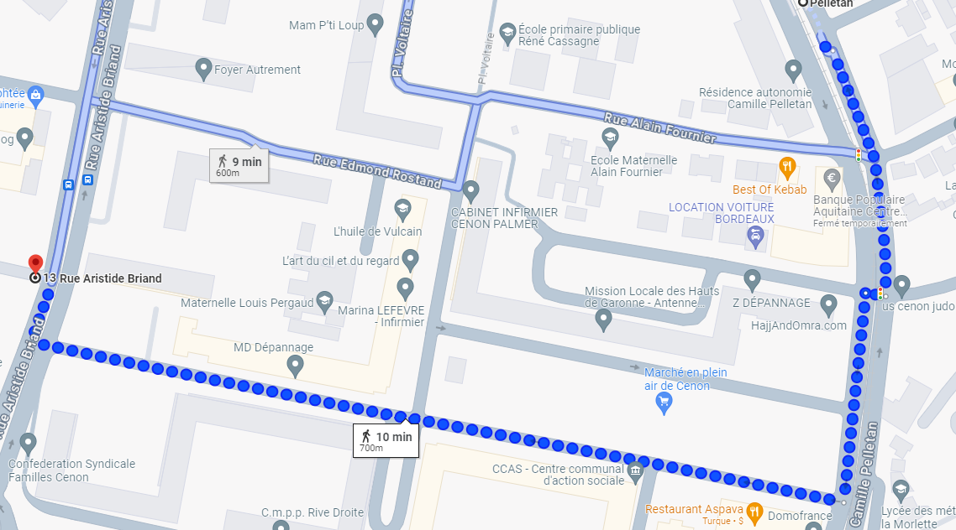

From Saint John Railway Station:

By tram
- Gare Saint-Jean -> "Porte de Bourgogne" stop
  - Line C Direction "Blanquefort station"
  - Or line D towards "Eysines Cantinolle"

- Stop 'Porte de Bourgogne' -> stop 'Pelletan'
Line A in the direction of "Floirac Dravemont"

- Walk between the "Pelletan" stop and the residence
https://goo.gl/maps/Q2jHd8XzCH1gde9p9

En TER + Tramway
- TER station Saint-Jean -> Cenon station
To find your TER, use the ter.sncf.com/nouvelle-aquitaine website
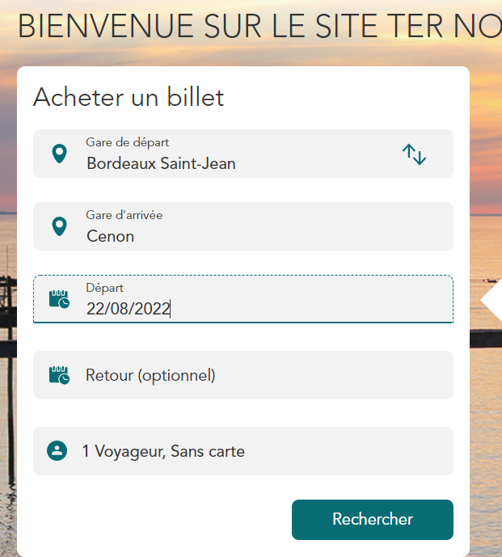
- Tramway Cenon station and stop -> stop 'Pelletan'
Line A in the direction of "Floirac Dravemont"
3) Walk between the "Pelletan" stop and the residence

Entrance to the residence's car park

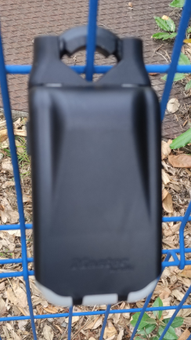
Retrieve the remote control and the key to the apartment door from the key box placed on the blue gate, to the right of the gate (lift the black part and then enter the access code (transmitted on the day of your arrival) from the 4 dials and open the box with it by pressing the black part with the arrow).
Please make sure that you use the 4 wheels each time you use them so as not to leave the code in plain sight.
The remote control allows you to open the gate and the door of the residence by placing it on the black circle to the right of the front door.

The apartment is on the 5th floor, door 56 (on the left when exiting the elevator, then at the very end of the hallway)

Shopping
- 800 meters from the residence: Supermarché Casino, Av. Roger Schwob, 33150 Cenon
- 1.4 kms from the residence: Carrefour Lormont, Route nationale, 10 Centre Commercial des 4 Pavillons, 33310 Lormont

WI-FI:
The apartment's network is the Livebox-FB90. (N.B. the power strip on the left of the TV stand must be started)
The code to access it is: nenf Mx9G MWNq ymyr Ep
(Do not enter spaces between character blocks).

Radiator

To turn on, press , the display shows the temperature Comfort: 19.0°C.- Press + or + to set the temperature.- If you are away from the apartment for a while, you can use the MODE button to choose ECO mode to lower the temperature selected above by 3°C

Multimedia:
The basic features are shown below, but the equipment guides are available in the sideboard under the TV.

Television set:
Select from the "INPUT" button on the TV remote control (HYNDAI remote control)
- HDMI3 source for Orange or Netflix channels
- HDMI 2 source for Chromecast
Netflix : The 'Appart 56' account allows you to access Netflix

Chromecast :
Instructions for use available here (skip to step 2)

Soundbar:
To stream, use from the remote control (see image below)
- TV sound: HDMI button
- That of a phone, tablet, etc. via Bluetooth: Bluetooth button (you will find the soundbar in the name of SAKOBS SB2122)
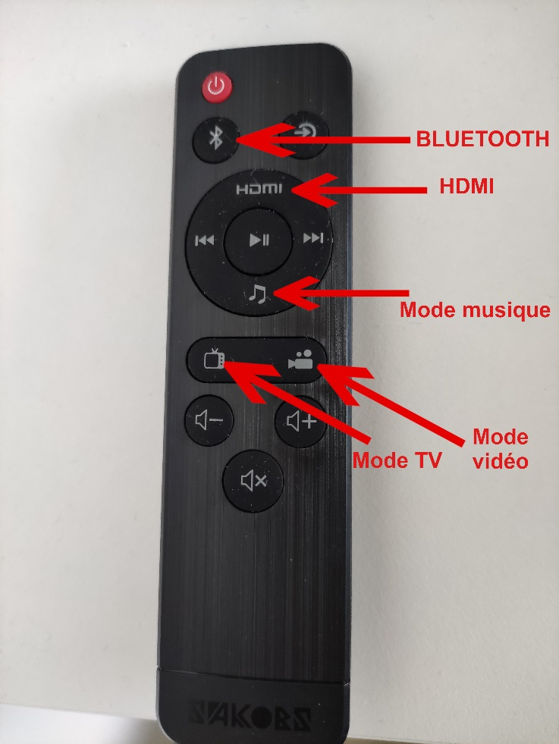

Outdoor fairy lights:
If the garland does not work, press one of the 2 buttons (1 for a solid light, the other for a flashing light)

Sofa bed:
A fabric handle on the back will help you unfold it

Cleaning:
Vacuum cleaners and a broom are located in the closet at the entrance of the apartment.

Garbage
You can deposit them in the bins located at the exit of the building, to the left of the entrance gate.

Outputs

Public transport
Tram & Bus: http://www.infotbm.com/
Vcub: https://www.vcub.fr/ River Shuttle
: http://www.infotbm.com/ligne/BatCub

The easiest way to get to the centre of Bordeaux from the residence is to take the Tramway line A.
- Tram access from the street: by walking to the "Pelletan" tram stop from the residence (600 meters on foot then 25 minutes by tram) -> Maps route: https://goo.gl/maps/Ccp8tJqkT9CpLM6q7

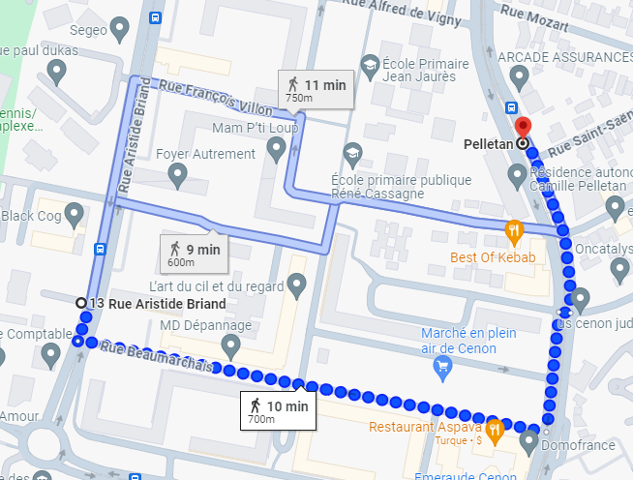

- Tram access via Palmer Park : By crossing Palmer Park on foot to reach the "Carnot - Mairie de Cenon" Tram A stop (1 km) from the residence. A little more walking but less travel time by Tram afterwards. A change of scenery guaranteed! You will take a path with a certain slope (downhill on the way to Bordeaux), so bring comfortable shoes. If it rains, it may have mud in some places.
- https://maps.app.goo.gl/KdoL3FG1jw9k1sQd9
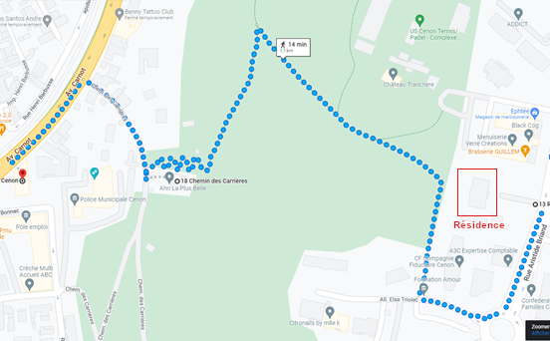

Near the apartment:
- Palmer Park (Palmer Park | Bordeaux Tourisme & Congrès (bordeaux-tourisme.com): Palmer Park offers 25 hectares of contrasting landscapes and a wide panorama of the Garonne undulating between two banks of the Bordeaux conurbation
One park, many uses.
Culture:
Château Palmer Cultural Centre, Music School, Green Theatre, Palmer Rock.
Nature:
Chestnut and plane trees, elms, beech trees, umbrella pines. Planting of 300 trees and 65 trees (oaks, plane trees, cedars, Scots pines and tulip poppies) every year to ensure the regeneration of the park.
Sports:
An athletics track, tennis and rugby courts, a city stadium, an orienteering course with four different circuits.
Trigger:
A children's playground accessible to disabled children, walking paths, two picnic areas (behind the Music School and at the bottom of the park behind the Town Hall, at the foot of the cliff).
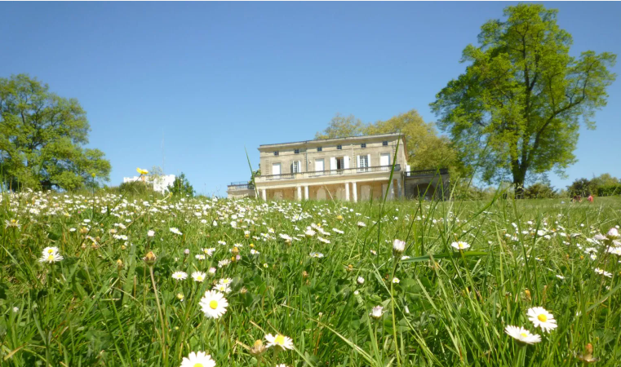

- Palmer's Rock Concert Hall (News | Rocher de Palmer - Cenon Bordeaux (lerocherdepalmer.fr)): Open since 2010 in the hollow of Palmer Park, the Rocher de Palmer is a must-see place in the metropolis dedicated to world cultures and music. Its 6700m2 of stages and studios, its 3 performance halls nestled under a red metal shell, host concerts, shows, exhibitions, symposiums and conferences all year round.
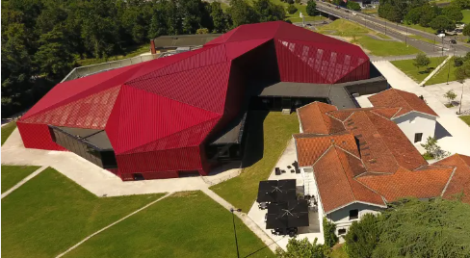

- The Elodie LORANDI Aqualudic Complex: Aqualudic Complex: A Swimmer's Guide! | Cenon Town Hall
Several pools:
  - The sports pool: with a surface area of 375m², a depth of 2 to 3 m, it is composed of 6 swimming lanes of 25 m.
  - The fun activity pool, balneotherapy, paddling pool: With a depth of 1.20m, it is ideal for awakening, learning or relaxation, since it includes 4 swimming lanes, massage jet benches, water games.
  - The wellness area: sauna, hammam.
  - Water play area (without depth) with about fifteen interactive games will delight the little ones in summer.
How to get there: https://goo.gl/maps/ZjpPetXFYFTLMq5S6

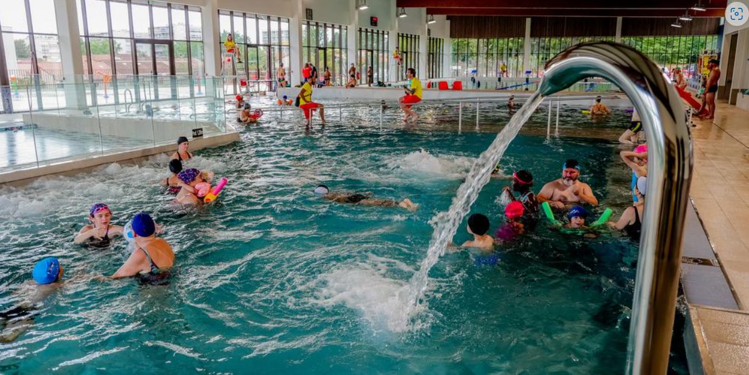

On the right bank of the Garonne:
- Darwin Ecosystem (Tram A, 'Botanic Garden' stop, Darwin Ecosystem, the Right Bank Alternative Place | Bordeaux Tourism & Convention (bordeaux-tourisme.com)): Darwin is a life-size playground for innovation. This former military barracks of nearly 20,000 m2, located on the right bank of the Quai des Queyries, is in constant effervescence. A sort of ideal city focused on the green economy with the creation of an urban farm, an XXL skate-park, spaces for free expression for graphic designers, an organic grocery store, a restaurant Le Magasin général, co-working spaces and even a bike-polo field. All decorated with the charm of recycling!
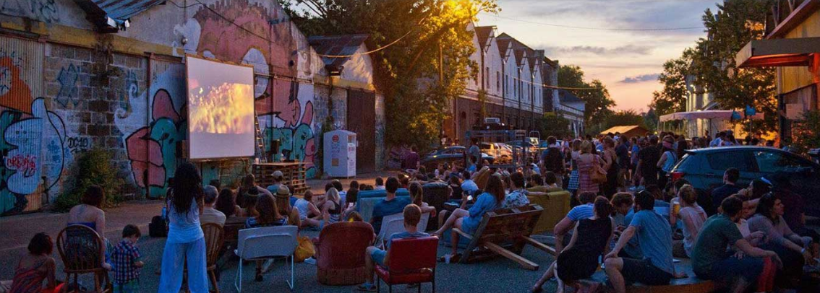

- The Botanical Garden (Tram A, "Botanical Garden" stop, Bordeaux Botanical Garden (jardin-botanique-bordeaux.fr)):
A botanical garden is a scientific and educational institution, designed to introduce all audiences to the world of plants, biodiversity, nature and the sustainable management of natural resources. An exceptional observation tool in an urban environment, it is a space for the exhibition and preservation of botanical heritage: an open-air part and a covered part called the Botanical City (greenhouse and exhibition rooms).

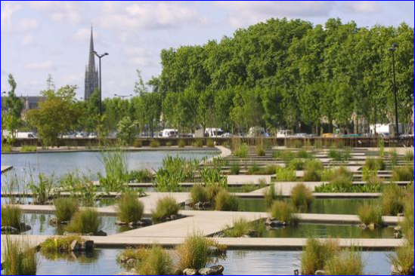

- La ginguette chez Alriq (Tram A, "jardin botanique" stop, Guinguette Chez Alriq Bordeaux - Catering & musical programme (laguinguettechezalriq.com)):
This open-air open-air open-air café offers a variety of live music, a restaurant serving simple dishes and a tapas bar.
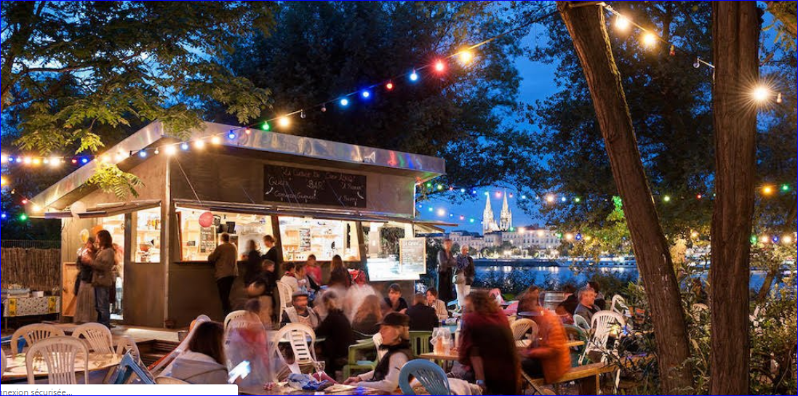

Cinema le Mégarama (17 screens) (Cinema Megarama in Bordeaux):
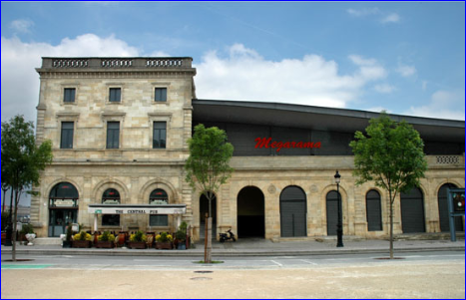

The historic centre of Bordeaux

Places to visit
- Left Bank Quays: In stroll, jogging or cycling mode, a stroll punctuated by green spaces, shops, playgrounds for children.
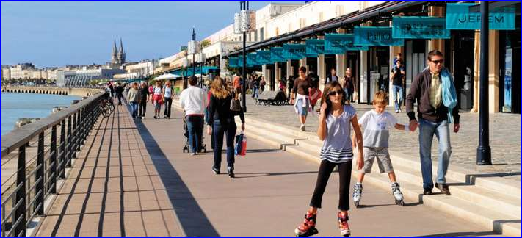
- The Cité du Vin (exhibition space on the theme of wine, ranked 7th among the best museums in the world, by National Geographic): https://www.laciteduvin.com/fr
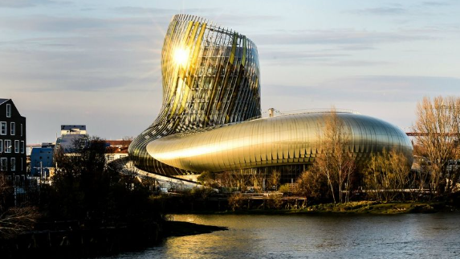

- The water mirror: It is less than 10 years old, but in front of a monumental building that is almost three centuries old, it is now the attraction. Located opposite the Place de la Bourse, between the Quai de la Douane and the Quai Louis XVIII, this spectacular work, by landscape architect Michel Corajoud, alternates extraordinary mirror and fog effects.
Please note that the water mirror is not in use during the winter due to maintenance (from November to April).

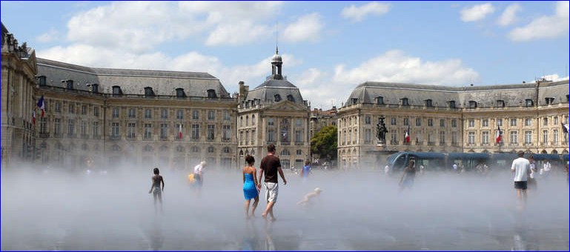

- Theatre: the Grand Théâtre has been shining for more than three centuries. Along with the opera houses of Versailles and Turin, the Grand Théâtre has one of the most beautiful eighteenth-century theatres in the world!
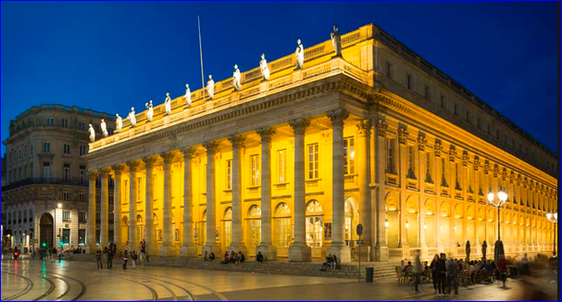

Also worth seeing: Cité du Vin, Public Garden, Pey Berland Tower and Saint-André Cathedral, Saint-Pierre district....
To visit Bordeaux according to your time, your tastes but also the news of the city, do not hesitate to contact the tourist office (12 Cr du 30 Juillet, 33000 Bordeaux Bordeaux Tourisme et Congrès: official website of the Bordeaux Métropole Tourist & Convention Bureau (bordeaux-tourisme.com))

Your departure:
Upon your departure, please leave the apartment in a clean and suitable condition.
- If using, turn off the radiator and heated towel rail
- Turn off the power strip on the left side of the TV stand.
- Place garbage cans in the outdoor area provided for this purpose.
- Place key and remote control in the outer key box.
Key box: please use the 4 wheels so as not to leave the code displayed.

Wishing you a most pleasant stay,
Ludovic

If the stay went well and you want to book the apartment again, you can make a "direct" booking via the website: https://www.sobdx.fr/
Do not hesitate to contact me if you have any questions (Tel: 07 77 28 19 94, email: letourneurludovic0@gmail.com)

