Room 101, "Les CÈDRES" Residence
20 avenue JEAN JAURÈS, CENON

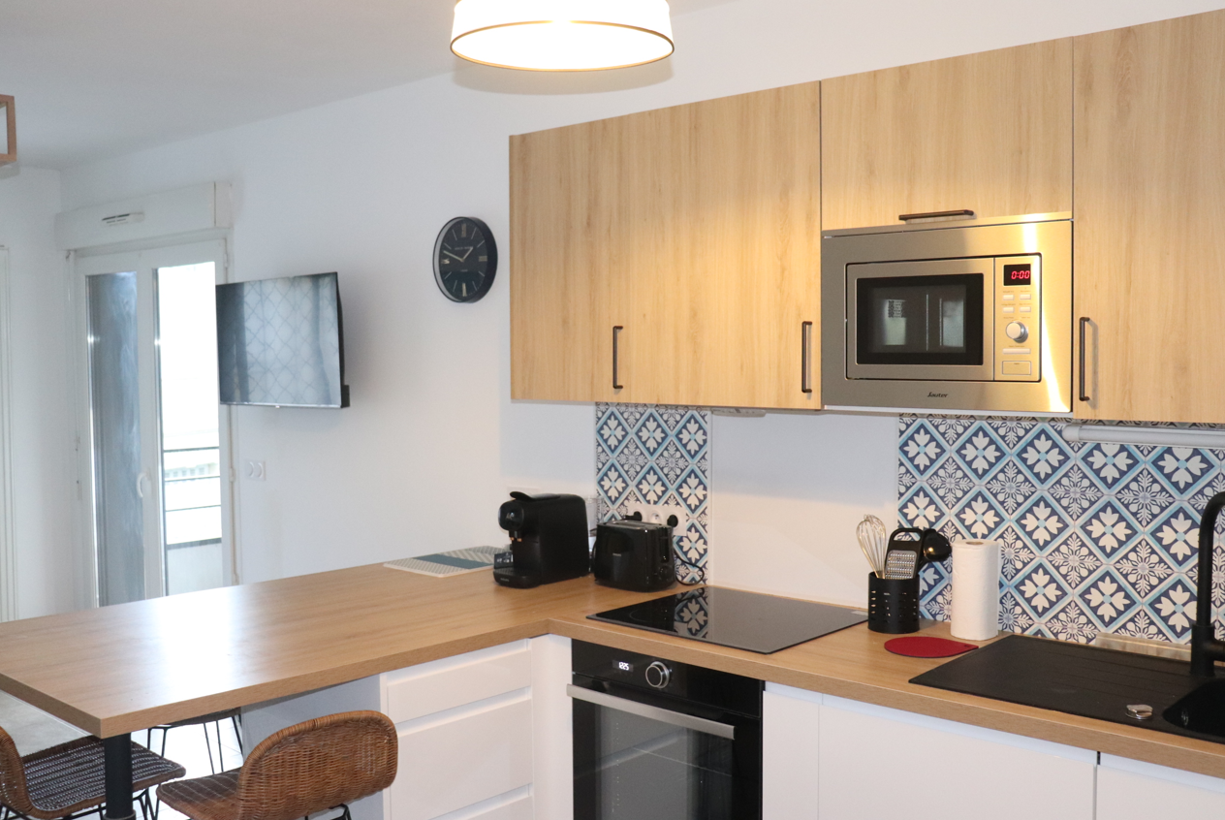

Welcome!

Having acquired this apartment in 2022, we were keen to renovate it and offer it today to travellers wishing to discover Bordeaux and the surrounding area.
As a reminder, as indicated in the Airbnb listing, this apartment is non-smoking and parties are not allowed.
We wish you a most comfortable and enjoyable stay in our apartment.
If necessary, we can be reached during your stay (Tel: 07 77 28 19 94, email: letourneurludovic0@gmail.com).

Ludovic

Table of Contents
Location Residence: 4
Access by public transport: 4
By tram 5
En TER + Tramway 5
Retrieve Keys 6
Entrance to the residence 8
- If you're driving 9
- If you are on foot 10
Salt, pepper, oil, vinegar: 10
Shopping 10
On the tram route to the residence 10
Close to the residence 10
Bakery 11
WI-FI: 11
Televisions: 11
Netflix 11
Sofa bed in the living room: 11
Dishwasher 11
Washing machine: 12
Cleaning: 12
Garbage 12
Outputs 12
Public transport 12
On the right bank of the Garonne: 12
The historic centre of Bordeaux 15
Places to visit 15
Your departure: 18

Location Residence:

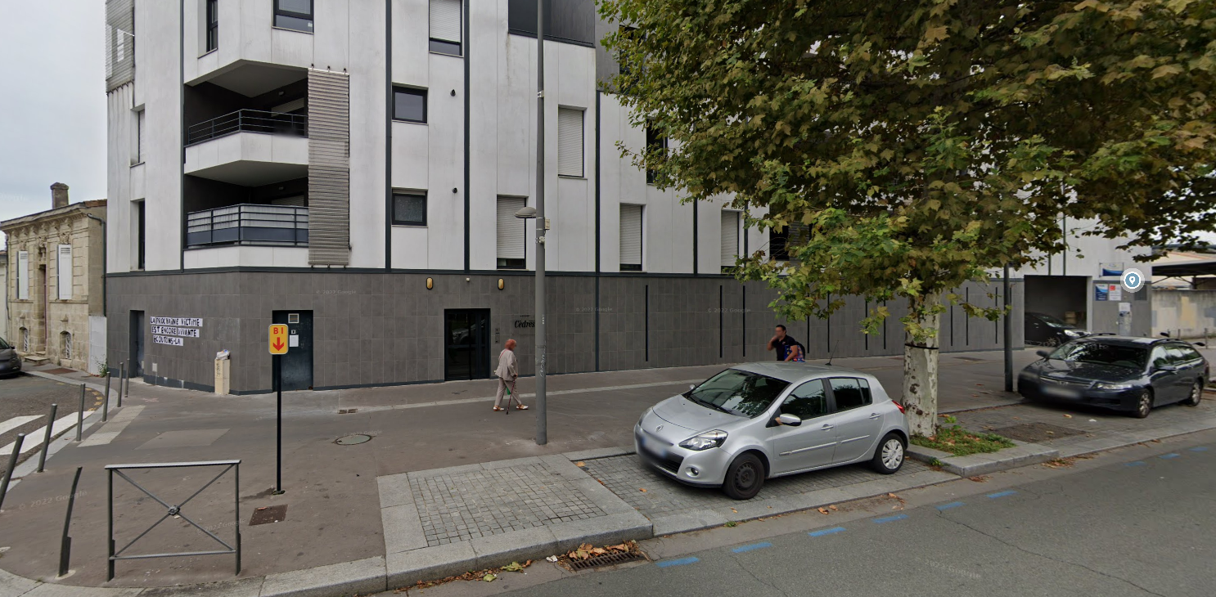
The residence is located at 20 avenue Jean Jaurès in Cenon. The Jean Jaurès tram stop on tram line A is 50 metres from the tram and Cenon Train Station is 350 metres away (1 tram stop).

Access by public transport:
From Bordeaux Airport
Tram A -> Direction "Floirac Dravemont" or "La Gardette" (journey time: 51 minutes)
Get off at the "Jean Jaurès" tram stop
Walk between the "Jean Jaurès" tram stop and the residence
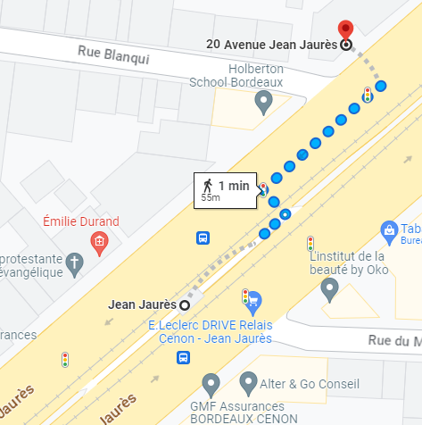

From Saint John Railway Station:

By tram
- "Gare Saint-Jean" - > "Porte de Bourgogne" stop
  - Line C Direction "Blanquefort station"
  - Or line D towards "Eysines Cantinolle"

- Stop 'Porte de Bourgogne' -> stop 'Jean Jaurès'
Line A in the direction of "Floirac Dravemont" or "La Gardette"

- Walk between the "Jean Jaurès" tram stop and the residence

En TER + Tramway
- TER "Gare Saint-Jean" -> "Gare de Cenon"
To find your TER, use the ter.sncf.com/nouvelle-aquitaine website
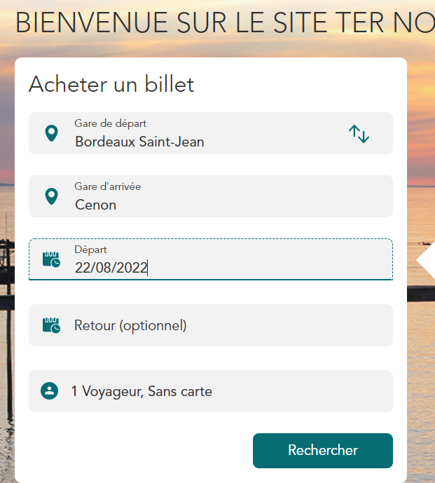
- On foot or by tram between the 'Gare de Cenon' stop and the 'Jean Jaurès' stop
Line A in the direction of "Le Haillan Rostand"
- On foot between the "Jean Jaurès" stop and the residence

Retrieve Keys


The keys can be picked up at 48 avenue Jean Jaurès.
If you are driving, you can park in front of the bakery.
The keys are on the beige grill protecting from the gas pipes. You have to walk around the gate to see the key box!
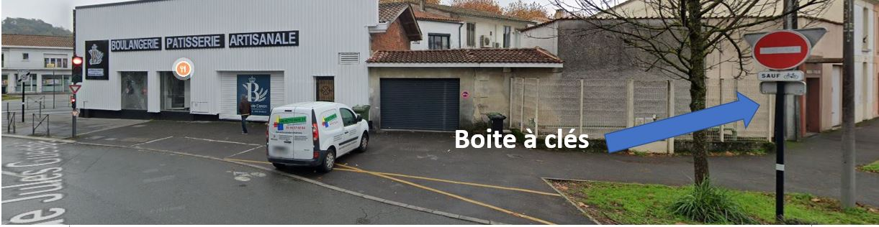

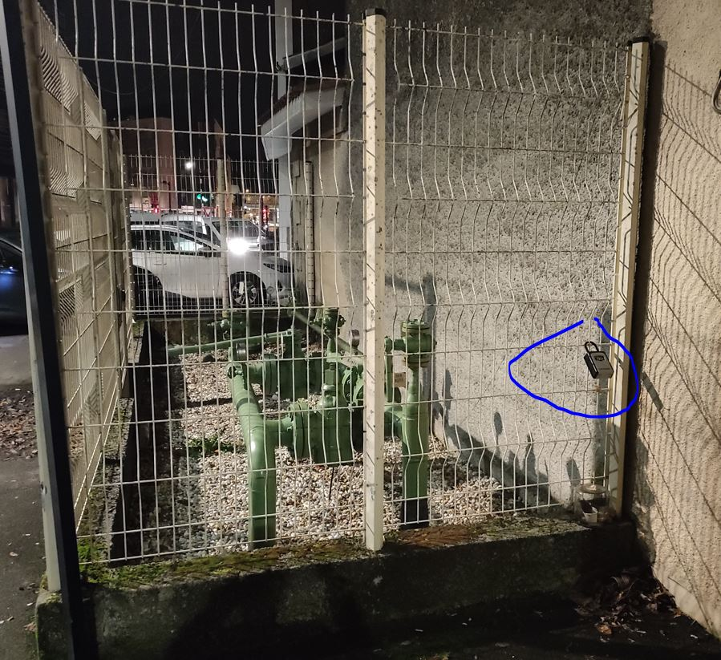
Once in front of the key box, you have to lower the black protection to reveal the 4 dials.
The 4-digit opening code will be communicated to you on the day of arrival.
Once the 4 digits have been entered, lower the black part to the left and pull towards you.
You will then have in your possession the badge to open the gate, the badge to open the front door and the key to the apartment.

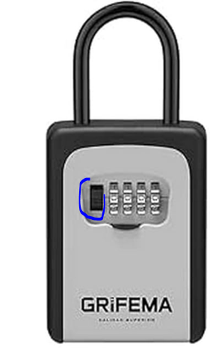
Please make sure, after each use, to handle the 4 wheels so as not to leave the code in plain sight and to reassemble the black protection.

Entrance to the residence

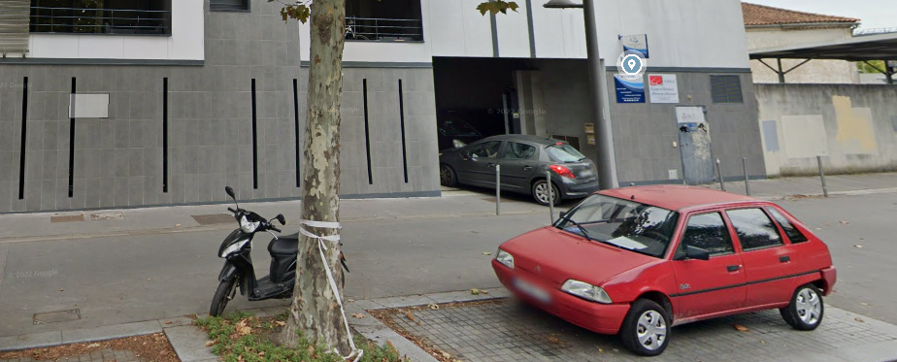

- If you are driving: Use the remote control to open the photo gate, take the entrance as shown in the photo, pass the covered car park and then take the path straight ahead to access the outdoor car park. The square (N°28) is at the back on the right.

Some parking spaces are allocated to the notary and accounting firm next to the residence. These spaces are indicated as such, but it happens that customers of these structures park by mistake on square N°28. If this is the case, take one of the free spaces in the car park (there are enough of them) while waiting for space 28 to become available during the day).
You can then retrace your steps on foot and go through the underground car park to take the back door, then a 2nd door before you can access the lift (Floor 1, apartment 101).
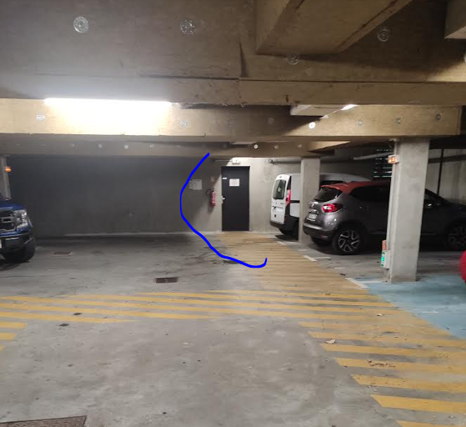

If you are on foot

Use the black badge to enter the residence. The elevator is then opposite
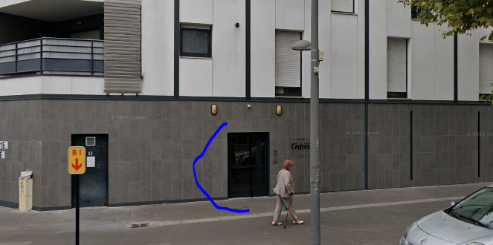

Then, retrieve the beep and the key from the apartment door in mailbox No. 101.

The apartment is on the 1st floor, door 101 (on the left as you exit the elevator).

Salt, pepper, oil, vinegar:
You'll find them in the spice base cabinet, located between the oven and the spice cabinet.

Shopping

On the tram route to the residence
  - Carrefour city, 293 Av. Thiers, 33100 Bordeaux in front of the 'Galin' tram stop (the one before the Jean Jaurès tram stop, in front of the residence). Open every day from 7 a.m. to 10 p.m. except Sundays from 9 a.m. to 1 p.m.

Close to the residence
  - 200 meters from the residence, "Carrefour city", at 54 avenue Jean-Jaurès.
Open every day from 7 a.m. to 10 p.m., except Saturday from 9 a.m. to 9 p.m. and Sunday from 9 a.m. to 1 p.m.
  - 200 meters from the residence, "la coop paysanne" at 57 Av. Jean Jaurès.
Open every day from 9 a.m. to 1:30 p.m. and from 3 p.m. to 7:30 p.m., except Sundays from 9 a.m. to 12:30 p.m. Closed on Mondays.
  - 400 meters from the residence, Aldi, 376 Av. Thiers, 33100 Bordeaux. Open every day from 8:30 a.m. to 8 p.m. except Sundays from 8:30 a.m. to 12:30 p.m.

Bakery
An artisan bakery is located at 48 Av. Jean Jaurès. It is open every day from 6 a.m. to 8 p.m.

WI-FI:
The apartment's network is the Livebox-9460. (If you need to restart the modem, it is on the left when you enter the apartment, in the electrical cabinet).
The password to access it is: cedres101 (A QR code is available in the apartment to connect to the network easily).

Televisions:
You can use the 'molotov' app installed on the 2 TVs to access your favorite programs.
The 2 TVs have a built-in Chromecast to cast the screen of your phone or tablet.

Netflix: The dedicated account is offered to you.

Sofa bed in the living room:
A fabric handle on the back will help you unfold it

Dishwasher : Dishwasher tablets are available under the kitchen sink.

Washing machine:
The tablets for the washing machine are available in the top drawer of the bathroom cabinet.
After use, please leave the washing machine door open.

Oven:
If the oven is ever locked, you can unlock it by pressing the – and + keys at the same time until the symbol disappears from the screen (this combination also works to lock the oven).

Cleaning:
A broom is available in the boiler cupboard, located next to the kitchen. You will find a vacuum cleaner in the bathroom closet.

Garbage
The garbage room is on the right as you exit the building.
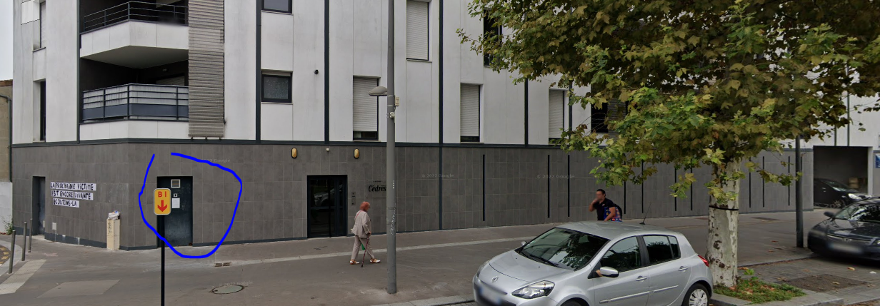

Outputs

Public transport
Tram & Bus: http://www.infotbm.com/
Vcub: https://www.vcub.fr/ River Shuttle
: http://www.infotbm.com/ligne/BatCub

On the right bank of the Garonne:
Living in the area, I can only highly recommend the following places!
- Darwin Ecosystem (Tram A, 'Botanic Garden' stop, Darwin Ecosystem, the Right Bank Alternative Place | Bordeaux Tourism & Convention (bordeaux-tourisme.com)): Darwin is a life-size playground for innovation. This former military barracks of nearly 20,000 m2, located on the right bank of the Quai des Queyries, is in constant effervescence. A sort of ideal city focused on the green economy with the creation of an urban farm, an XXL skate-park, spaces for free expression for graphic designers, an organic grocery store, a restaurant Le Magasin général, co-working spaces and even a bike-polo field. All decorated with the charm of recycling!
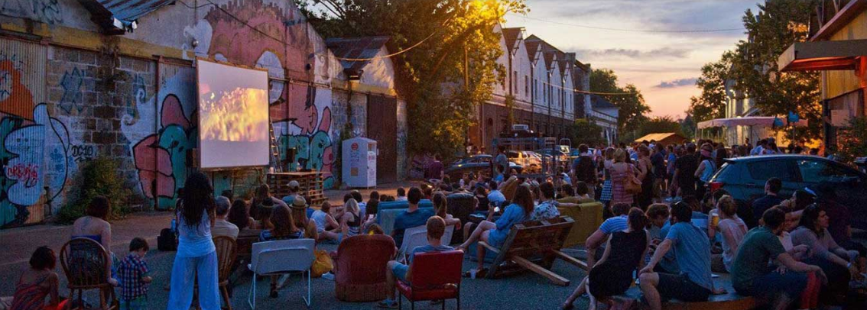

- The Botanical Garden (Tram A, "Botanical Garden" stop, Bordeaux Botanical Garden (jardin-botanique-bordeaux.fr)):
A botanical garden is a scientific and educational institution, designed to introduce all audiences to the world of plants, biodiversity, nature and the sustainable management of natural resources. An exceptional observation tool in an urban environment, it is a space for the exhibition and preservation of botanical heritage: an open-air part and a covered part called the Botanical City (greenhouse and exhibition rooms).

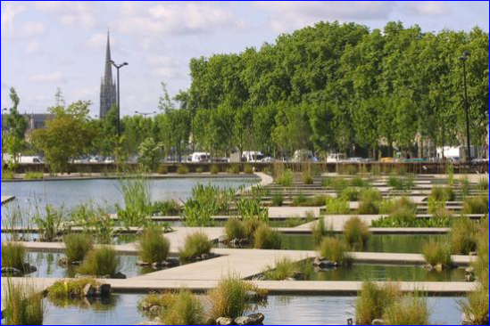

- La ginguette chez Alriq (Tram A, "jardin botanique" stop, Guinguette Chez Alriq Bordeaux - Catering & musical programme (laguinguettechezalriq.com)):
This open-air open-air open-air café offers a variety of live music, a restaurant serving simple dishes and a tapas bar.
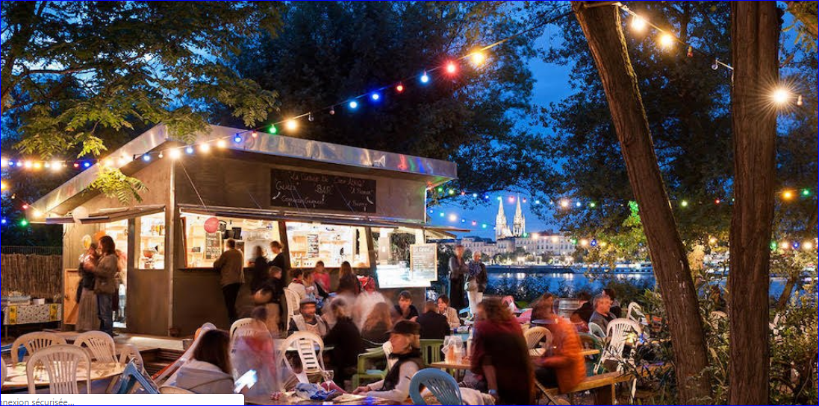

Cinema le Mégarama (17 screens) (Cinema Megarama in Bordeaux):
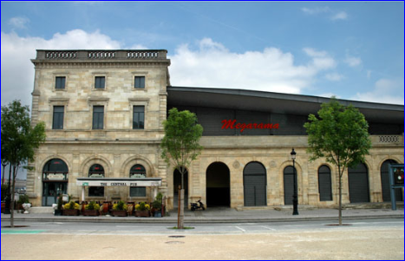

Restaurants :
You'll be spoilt for choice in the historic centre of Bordeaux. Near the apartment, we can recommend these 2 places that we really like:
- 350 meters from the residence: MORUES & TAPAS, 358 Av. Thiers, 33100 Bordeaux
- 1.7 from the apartment (2 tram stops): Côté Zinc, 129 Av. Thiers, 33100 Bordeaux

The historic centre of Bordeaux

Places to visit
- Left Bank Quays: In stroll, jogging or cycling mode, a stroll punctuated by green spaces, shops, playgrounds for children.
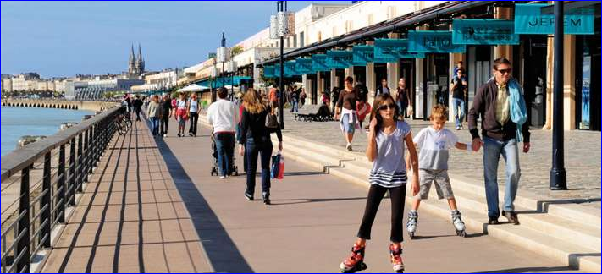
- The Cité du Vin (exhibition space on the theme of wine, ranked 7th among the best museums in the world, by National Geographic): https://www.laciteduvin.com/fr
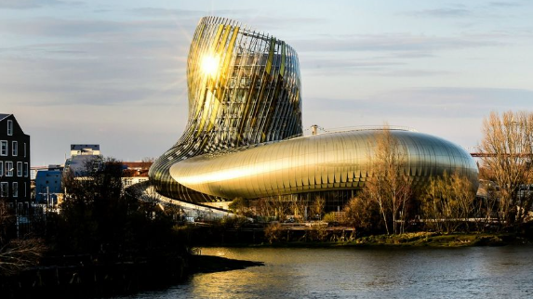

- The water mirror: It is less than 10 years old, but in front of a monumental building that is almost three centuries old, it is now the attraction. Located opposite the Place de la Bourse, between the Quai de la Douane and the Quai Louis XVIII, this spectacular work, by landscape architect Michel Corajoud, alternates extraordinary mirror and fog effects.
Please note that the water mirror is not in use during the winter due to maintenance (from November to April).

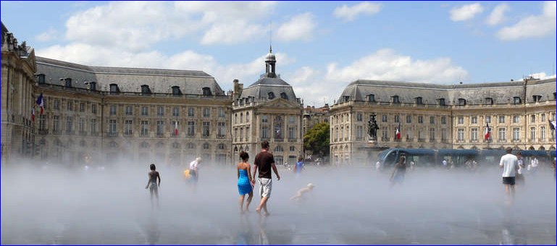

- Theatre: the Grand Théâtre has been shining for more than three centuries. Along with the opera houses of Versailles and Turin, the Grand Théâtre has one of the most beautiful eighteenth-century theatres in the world!
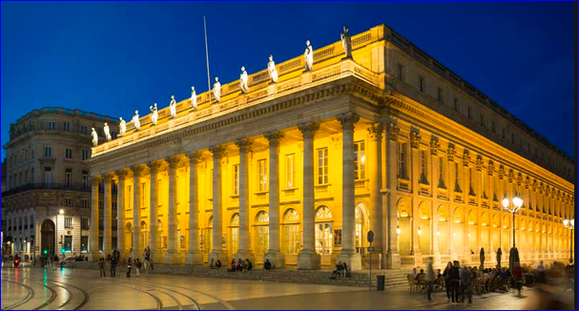

- The Bassin des Lumières: The Bassins des lumières, the largest digital art centre in the world, is located in the former submarine base in Bordeaux. Monumental immersive digital exhibitions dedicated to the great artists of art history and contemporary creation are presented.
Bassins des Lumières - Official site - Managed by Culturespaces (bassins-lumieres.com)

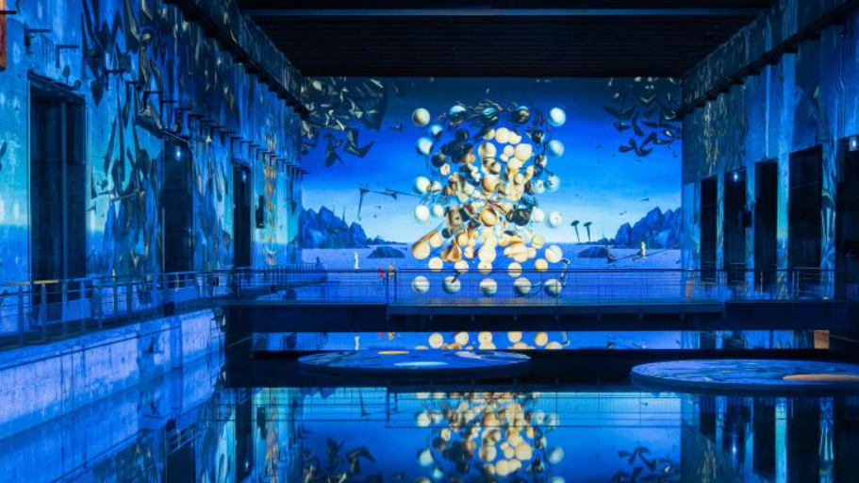

Also worth seeing: Cité du Vin, Public Garden, Pey Berland Tower and Saint-André Cathedral, Saint-Pierre district....
To visit Bordeaux according to your time, your tastes but also the news of the city, do not hesitate to contact the tourist office (12 Cr du 30 Juillet, 33000 Bordeaux Bordeaux Tourisme et Congrès: official website of the Bordeaux Métropole Tourist & Convention Bureau (bordeaux-tourisme.com))

Your departure:
Upon your departure, please leave the apartment in a clean and suitable condition.
- Turn off the thermostat by setting it to the
- Place the garbage in the room provided for this purpose, to the right of the front door, when leaving the building.

Drop off the key set in mailbox No. 101 (in the name of 'LETOURNEUR') located at the entrance of the building.

Wishing you a most pleasant stay,
Ludovic

If the stay went well and you want to book the apartment again, you can make a "direct" booking via the website: https://www.sobdx.fr/
Do not hesitate to contact me if you have any questions (Tel: 07 77 28 19 94, email: letourneurludovic0@gmail.com)

