J404 apartment, Résidence l'AVANT-PREMIERE

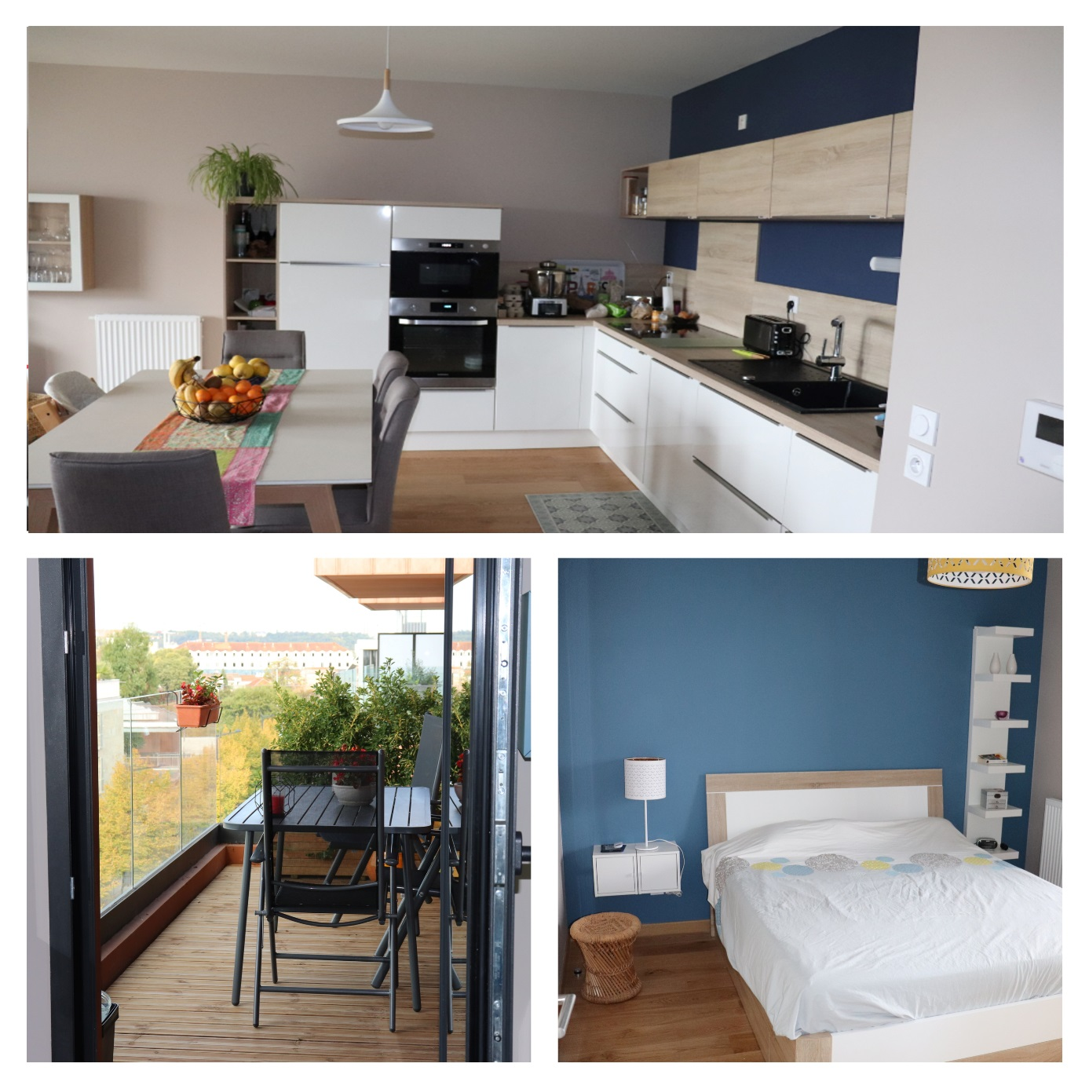

Welcome to our home!

Installed in this apartment since February 2019, we move regularly during our holidays and weekends. We have decided to offer it to travellers wishing to discover Bordeaux.
As a reminder, as indicated in the Airbnb listing, this apartment is non-smoking and parties are not allowed.
We wish you a most comfortable and enjoyable stay in our apartment.
If necessary, we remain reachable during your stay (Tel: 07 77 28 19 94, email: letourneurludovic0@gmail.com).

Ludovic & Charline

Table of Contents
Keys, badges 4
Apartment access: 4
From the street: 4
Through the garage of the residence 6
Shopping 7
Eating at the apartment: 7
WI-FI, Appliance and HIFI Guide: 7
WI-FI: 7
Plaque induction : 7
Microwave: 8
Oven: 9
Coffee machine 10
Bluetooth adapter 13
Dishwasher 13
Cleaning: 14
Garbage 14
Things to do Error! Bookmark not set.
Near the apartment: 14
The centre of Bordeaux 16
Access 16
To visit 17
Your departure: 18

Keys, badges

You will have at your disposal:
- A badge to enter the residence and the building
- A key to the front door of the apartment
- Controlling the garage gate
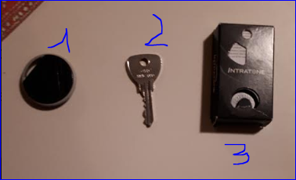

Apartment access:

From the street:

The building is located at 35 rue Léonce Motelay:

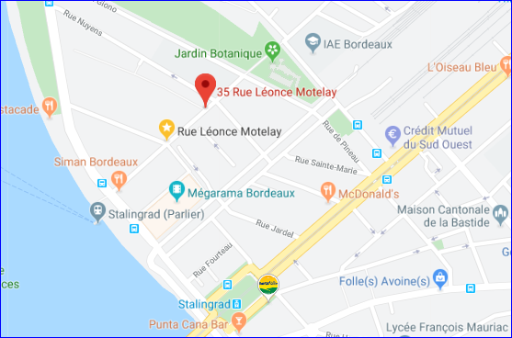

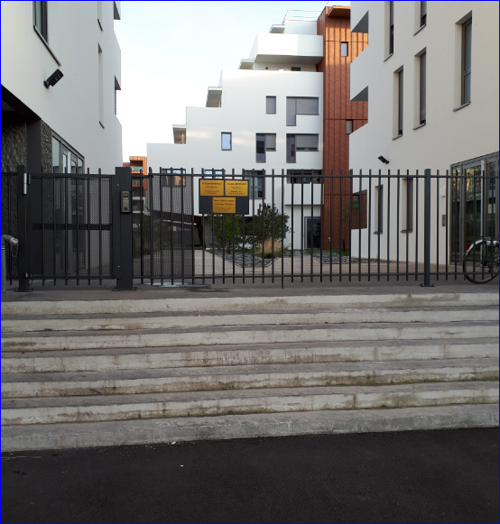

Entry into the residence through the gate is done by affixing the access badge to the black circle bearing the inscription 'VIGIK' and then by pulling on the gate:

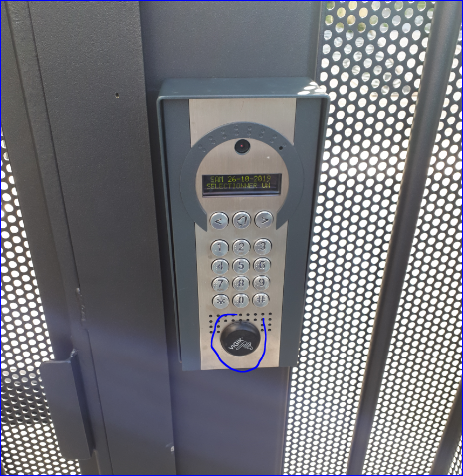

To enter the residence (building J to the right of the gate), use the access badge again and in the elevator also before choosing the floor:
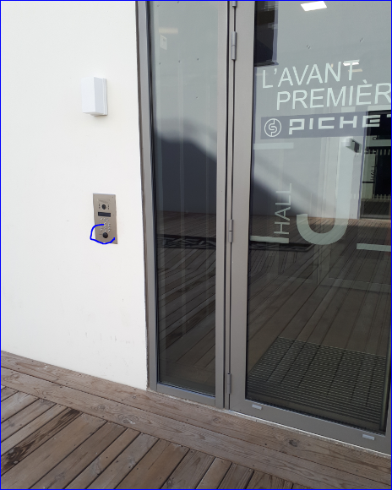
The apartment is on the 4th floor, door 404.

Through the garage of the residence
Access to the residence's garage is via Rue Louis Emie (perpendicular to Rue Léonce Motelay). Use the command to open the portal:
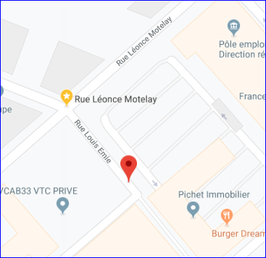

After the slope of the garage entrance, turn right several times to access square 161.
Then take the door in front of the parking space to take the elevator and go up to the 4th floor.

Shopping
A crossroads market is located on Allée Serr, a 3-minute walk from the apartment.

Eating at the apartment:
Coffee, tea, salt, pepper, vinegar, oil and sugar are at your disposal.

WI-FI, Appliance and HIFI Guide:

WI-FI:
The network of the apartment is the Livebox-FE50.
The code to access it is: XbyJnL7H5y6lcvHrTW

Plaque induction :

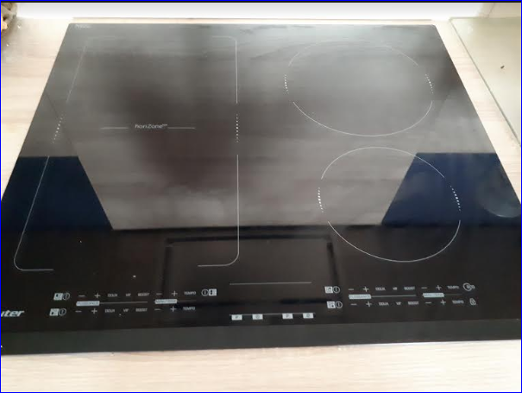

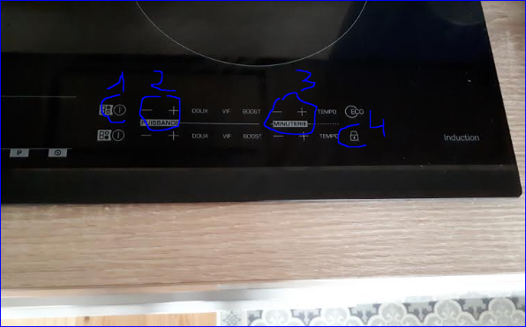
For each of the 4 zones:
1 -> Starting the Plate
2 -> Power Adjustment
3 -> Timer Setting
If you press the padlock (4) inadvertently, the 'block' inscription will flash and the plate will be locked. Then press the padlock again for a few seconds to unlock the plate.

Microwave:

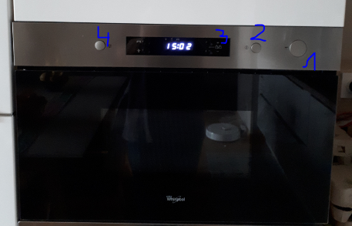

- Opening the door
- Adds 30 seconds of cooking time with each press
- Allows you to adjust the time/temperature
- Stops cooking

Oven:

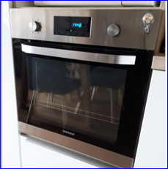

To use the oven:
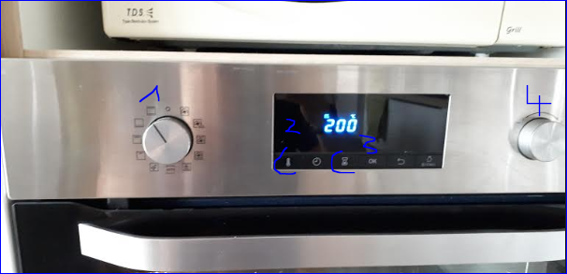

- Turn Dial 1 to the left to use the oven's default cooking mode
- Press 2 to select the temperature and then dial 4 to lower or increase it
- Press 3 to select the time and then dial 4 to lower or increase it
If necessary, refer to the oven documentation located on the dining room table.

Coffee machine

NB: before starting and stopping the machine, make sure to put a cup under the nozzles of the machine because the machine, to clean itself, evacuates water when starting and stopping.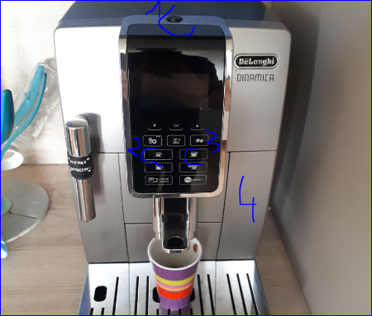
- Machine start/stop
- Press 2 to select an espresso or 3 for a long coffee
If a message is received to fill the water tank, pull the tank (4) towards you to fill it
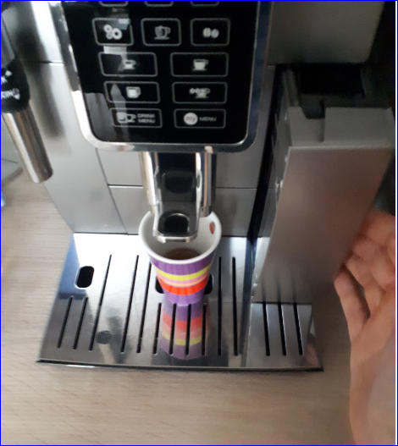

If the machine indicates that the grounds tank is full, open the lower drawer:
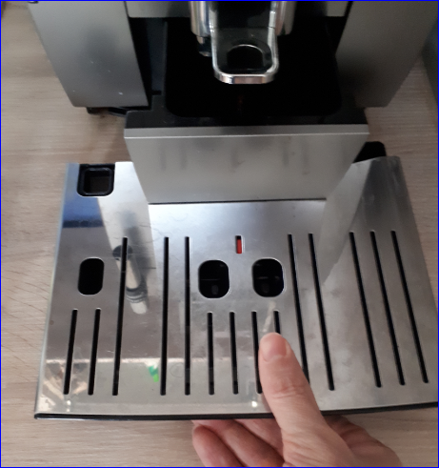

Then empty the contents of the grounds tank into the garbage can:
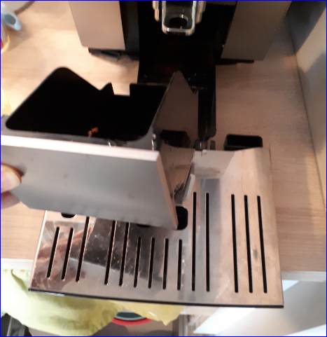

TV/amplifier
To turn on the TV and amplifier, start the power strip, located on the back left of the TV stand.
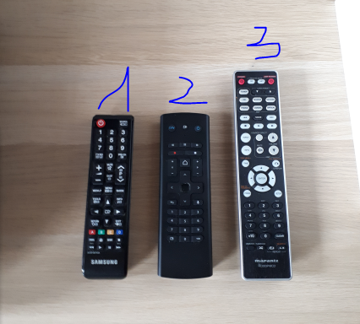
- Start the TV with the remote control 1. The TV must be on the source
HDMI 1. If not, press the 'source' button at the top right of the remote control until the HDMI1 source is displayed on the screen.
- Start the TV set-top box with the remote control 2. Started, the red light should change to green.
- Start the amp with remote control 3 ('amp power' button to the right of the remote control). The amp should be positioned in the 'optical 2' position to deliver the sound of the TV. If not, turn the left source selection knob (1). Then use the right button to adjust the volume if needed (2)

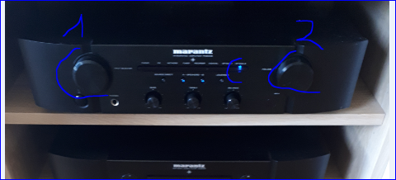

Bluetooth adapter

You can connect a phone, tablet to stream your music on the amp. To do this, press the button on the Bluetooth adapter shown below for a few seconds:
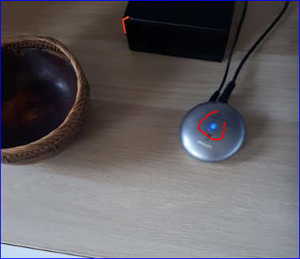

The adapter light is flashing. You can then select the 'PHILIPS AEA2700' element on your phone or tablet to link it and stream your music. The amp should be positioned in the 'optical 1' position. If not, turn the left source selection knob (see above the 'TV/amplifier' section)

Dishwasher

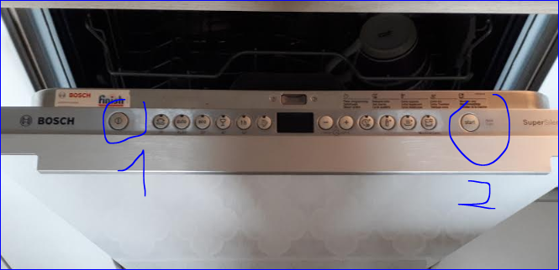

- Start the dishwasher
- Press 'Start' to start washing

Cleaning:
If necessary, a vacuum cleaner and a broom are located in the cupboard just next to the front door of the apartment.

Garbage
If necessary, the garbage room is located opposite the exit of the building. It opens and closes with the same key as the apartment.
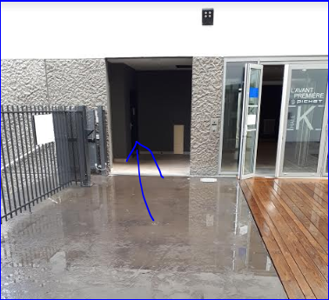

Outputs

Near the apartment:
- Darwin ecosystem: Darwin is a life-size playground for innovation. This former military barracks of nearly 20,000 m2, located on the right bank of the Quai des Queyries, is in constant effervescence. A kind of ideal city focused on the green economy with the creation of an urban farm, an XXL skate park, spaces for free expression for graphic artists, an organic grocery store, a restaurant Le Magasin général, co-working spaces and even a bike-polo field. All decorated with the charm of recycling!
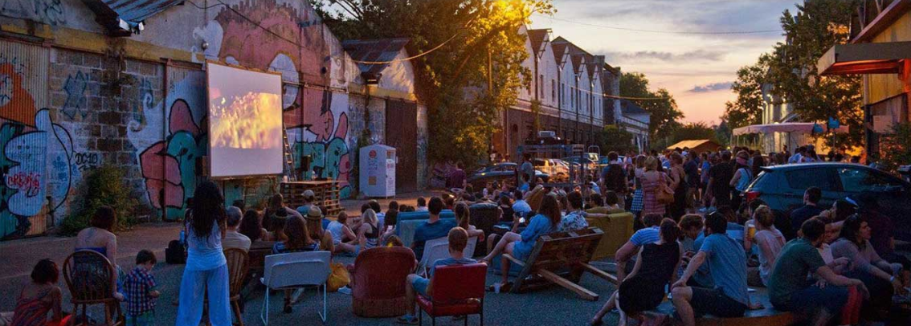

- The botanical garden:
A botanical garden is a scientific and educational institution, intended to introduce all audiences to the world of plants, biodiversity, nature and the sustainable management of natural resources. An exceptional observation tool in an urban environment, it is a space for exhibition and preservation of botanical heritage: an open-air part and a covered part called the Cité botanique (greenhouse and exhibition rooms).

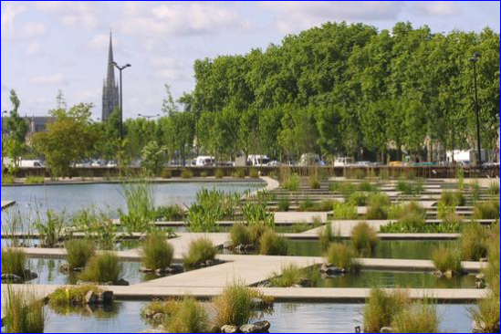

- The ginguette at Alriq:
This open-air guinguette offers a variety of live music, a simple dishes restaurant and a tapas bar.
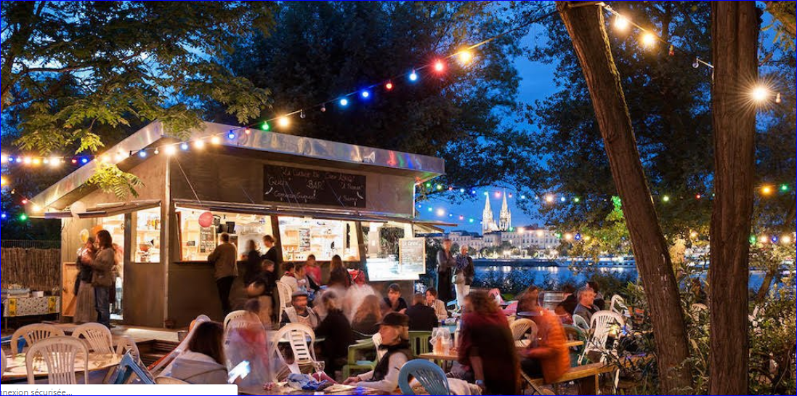

Cinema le Mégarama (17 screens):
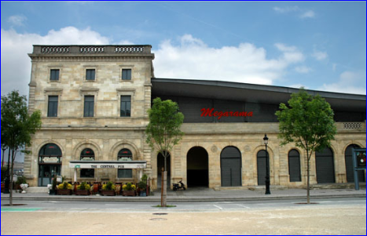

The centre of Bordeaux

Access
- On foot: cross the stone bridge
- The Batcub: a river shuttle allows you to cross the Garonne. The pier is located 200 metres from the apartment (shuttle bus approximately every 45 minutes)
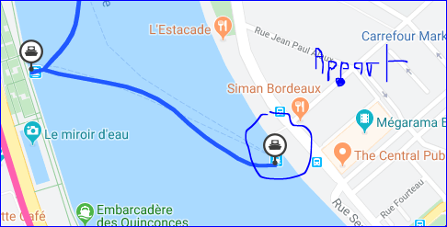
- By tram: to get to the tram (Tramway line A, stop at Place Stalingrad):
Turn left as you leave the building, then follow the Garonne, then the tram stop is on your left, Place Stalingrad.

To go to the centre of Bordeaux, take the tram in the direction of the Pont de Pierre.
To use public transport, do not hesitate to use the infotbm.com website or the TBM smartphone application

To visit
- Quays on the left bank: In strolling, jogging or cycling mode, a stroll punctuated by green spaces, shops, playgrounds for children.
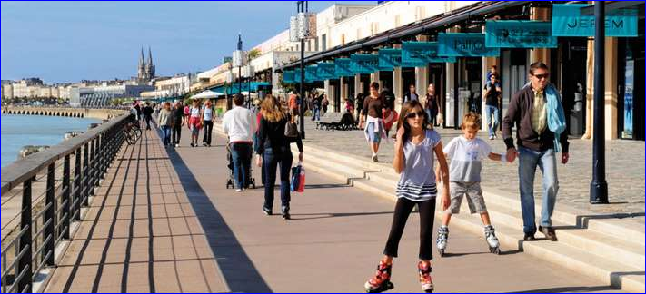

- The water mirror: It is less than 10 years old, but faced with a monumental building that is almost three centuries old, it is now the attraction. Located opposite the Place de la Bourse, between the Quai de la Douane and the Quai Louis XVIII, this spectacular work, by the landscape architect Michel Corajoud, alternates extraordinary effects of mirror and fog.
Please note that the water mirror is not in service during the winter due to maintenance (from November to April).

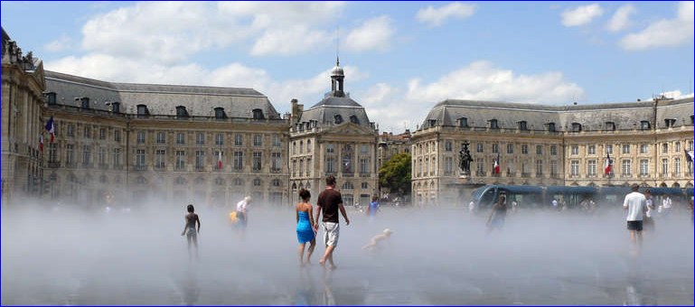

- The theatre: the Grand Théâtre has been shining for more than three centuries. With the opera houses of Versailles and Turin, the Grand-Théâtre has one of the most beautiful eighteenth-century performance halls in the world!
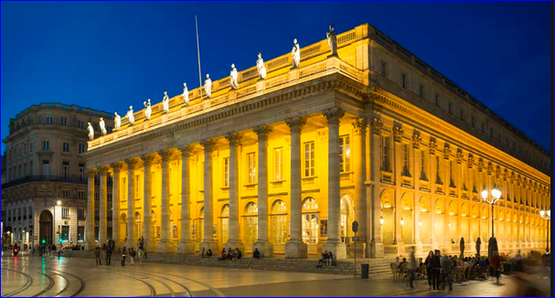

Also worth seeing: Cité du Vin, public garden, Pey Berland Tower and Saint-André Cathedral, Saint-Pierre district....

Your departure:
When you leave, please lock the front door of the apartment and leave the keychain with the key, the entrance badge and the garage gate order in the mailbox at the entrance to the building (J404).

